**Sampling novel Sequences**

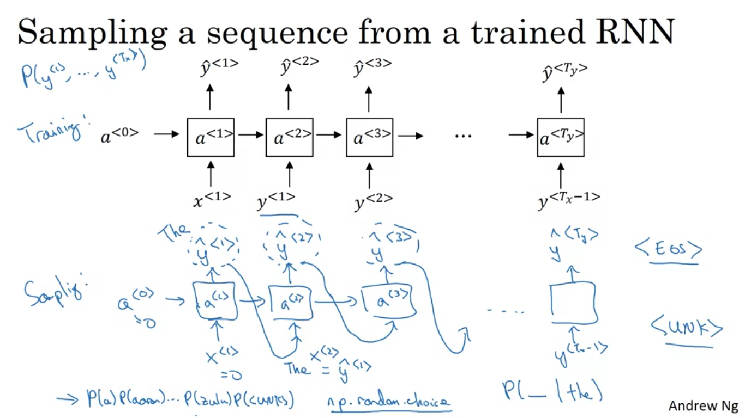

**Character level language model**

Disadv:

1. Computationally expensive

2. Much longer sequences

3. does not catch longer word sequences

